**Verification & Validation**

Design and Analysis of a Robust and Portable Evaluation System for Resonant Based Silicon Photonic Biosensors [SFT]

**Client:**

Faculty of Applied Science System-on-a-Chip Research lab

Ben Cohen, April 2025

**Prepared by**:

Callum O’Riley, Peter van den Doel, Tenna Yuan, Bennett Galamaga, Suhail Khalil, James Marx. [Capstone team 81]

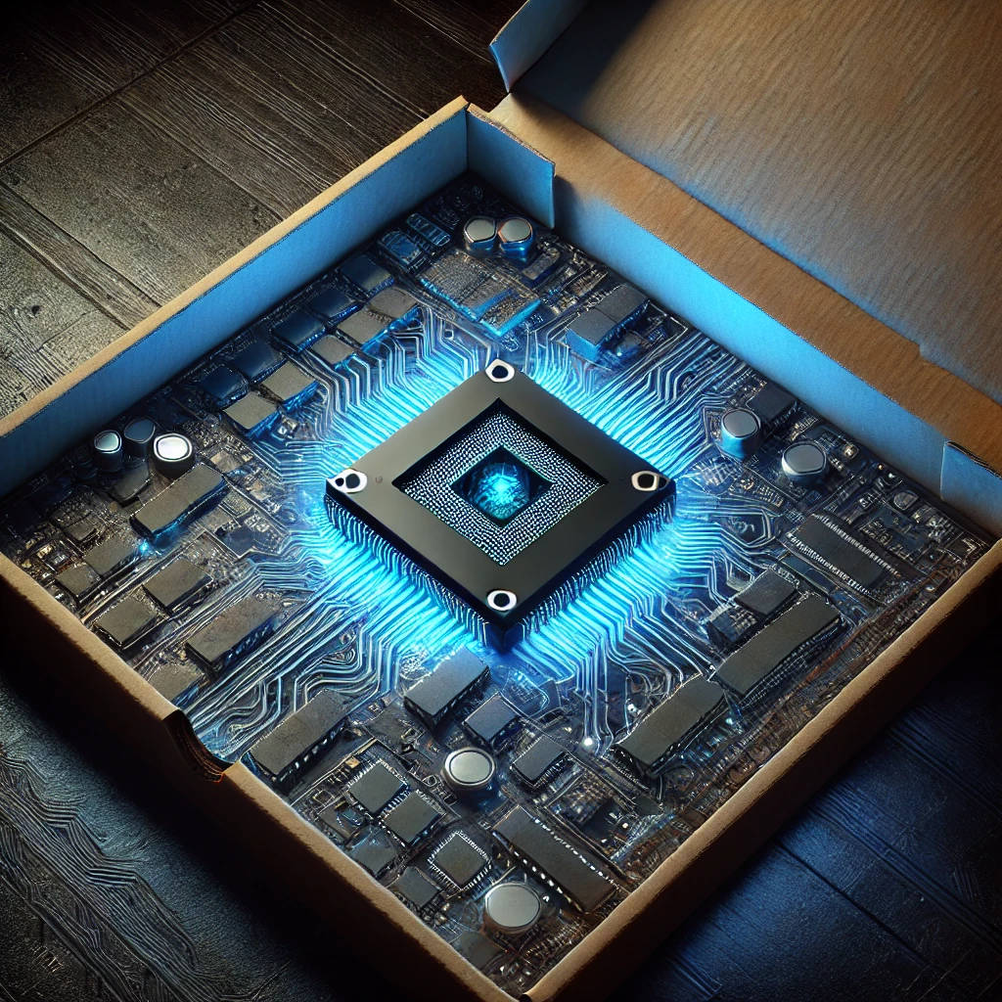

Figure 1. Imagined result chip. Source [1]

Table of Contents

**1 Overview 2**

1.1 Requirements, Constraints, Goals 3

1.2 List of Devices Used 4

**2 Verification Test Descriptions and Results 5**

2.1 PD-TIA Calibration 5

2.2 TIA Noise 9

2.3 PD-TIA-ADC Basic Functionality 10

2.4 Laser Characterization Comparison 12

2.5 Sweep Repeatability 15

2.6 Comparison with Benchtop Setup 17

2.6 Laser Temperature Control 20

2.7 PIC Stage Temperature Control 22

**3 Validation 23**

3.1 Requirements 24

3.2 Goals 25

**4 References 26**

**Appendix A: Glossary 27**

# 

# 1 Overview

The verification of this project is a process that is engaged in continuously throughout the term. The intended photonic integrated circuit to be used with this project was not fabricated in time for us to test with, so the client provided us with a similar photonic resonator called a fiber Fabry-Perot. The fiber Fabry-Perot is a packaged photonic resonator that, similar to our chip, has optical fibers as the interfaces, and requires temperature control to maintain a stable response. The fiber Fabry-Perot temperature control setup is shown in Figure 1.1.

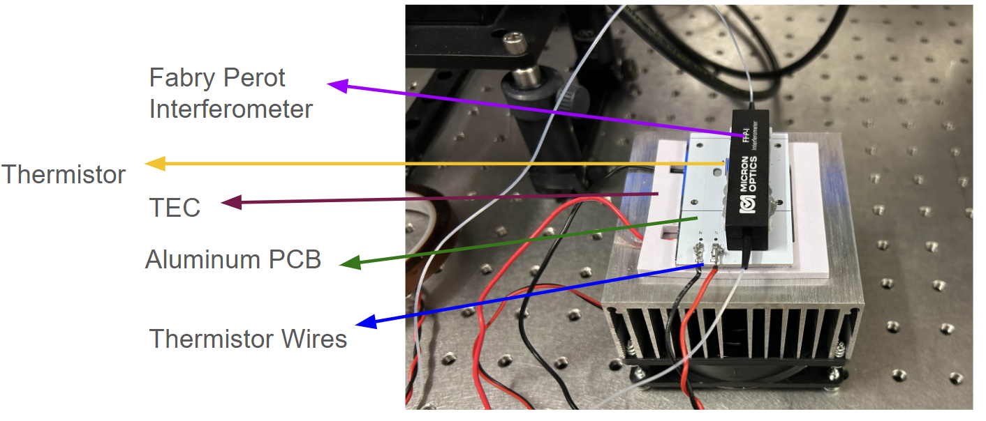

*Figure 1.1: Fiber Fabry-Perot temperature control set up. The resonator is attached onto the eval system’s mechanical setup for temperature control using thermal paste.*

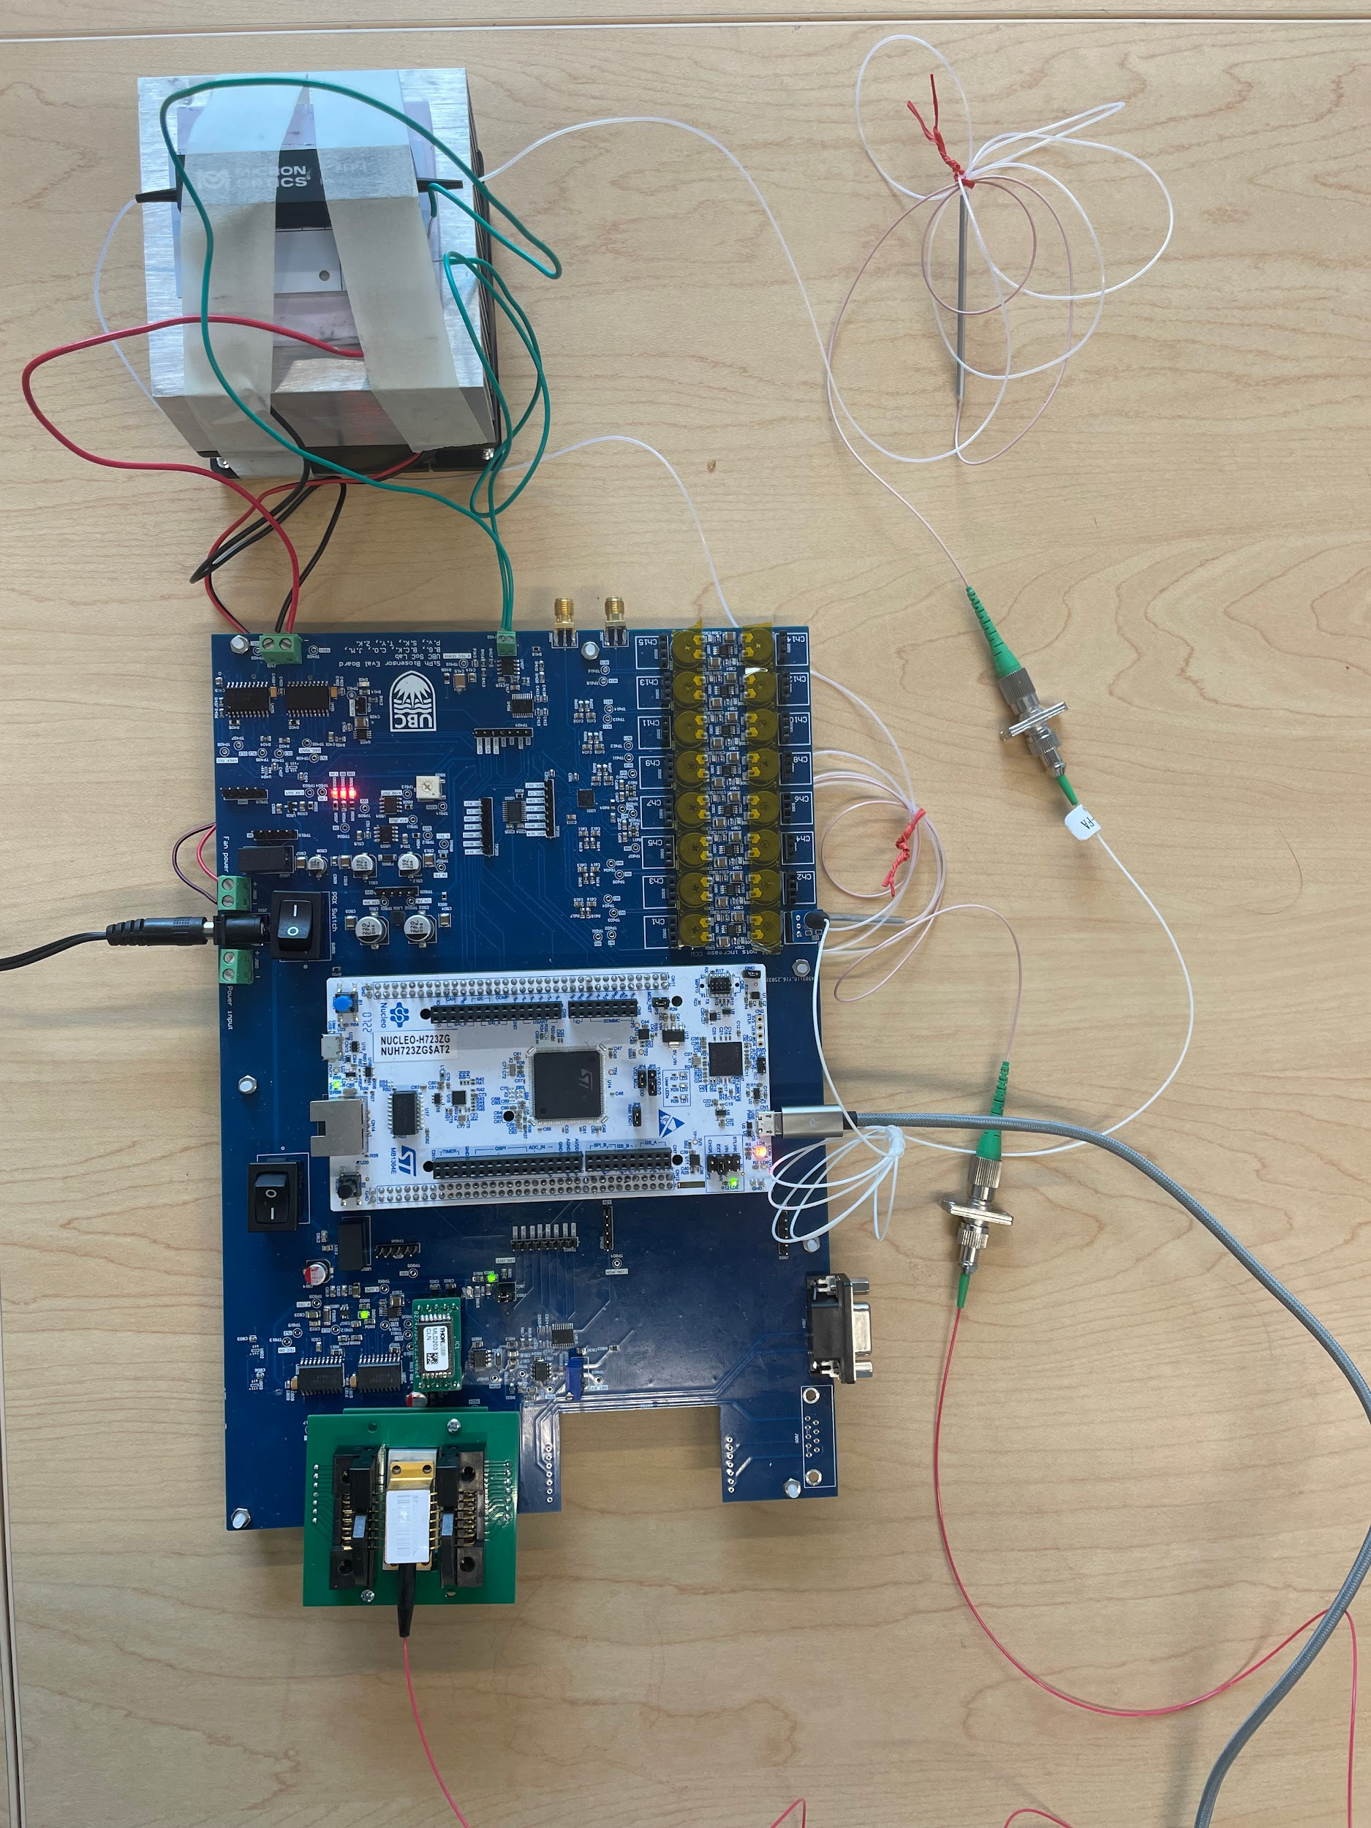

*Figure 1.2: Test setup for the PRX board and the custom laser diode controller. The resonator is attached to one of the photodiode channels through an optical fiber, and the butterfly laser is connected at the other end. The TEC and thermistor are connected through wires into screw terminals.*

Benchtop instruments are used as points of comparison against our custom instruments, and are also used as reliable data acquisition sources to gauge the performance of various elements within the system. A Keysight tunable laser is used as a reliable laser to characterize our photodetectors and validate the photonic power measurement requirement (RS-1). A Keysight photodetector is used as a very low noise optical power meter to characterize the performance of our laser driver and controller. The test setup for the evaluation system is shown in Figure 1.2. A combination of a Keysight photodetector and Keysight laser are used to accurately characterize our fiber Fabry-Perot resonator. The temperature of the fiber Fabry-Perot and the laser are controlled using the two temperature controllers on the evaluation system, to achieve required thermal control (RS-4).

## 1.1 Requirements, Constraints, Goals

| **Identifier** | **Name** | **Status** | **Relevant tests** |
| --- | --- | --- | --- |
| RS-1 | Photonic power measurement | Satisfied | 2.1, 2.2, 2.3, 2.5 |
| RS-2 | Resolution of peak detection | Satisfied | 2.5 |
| RS-3 | Repeatability of peak detection | Satisfied | 2.5 |
| RS-4 | Thermal control | Satisfied | 2.6, 2.7 |
| RS-5 | Software control and data acquisition | Satisfied | 2.5, 2.6, 2.7, 2.8 |
| RS-6 | Photonic device hotswapping | Set in design | --- |
| RS-7 | Robustness | Set in design | --- |
| RS-8 | PID Controller Tunability | Satisfied | 2.6, 2.7 |
| RS-9 | Photonic measurement noise floor | Satisfied | 2.2 |
| RS-10 | Tunable Output Wavelength | Set in design | --- |

*Table 1.1: Progress of requirements*

| **Identifier** | **Name** | **Status** | **Relevant tests** |
| --- | --- | --- | --- |
| CS-1 | Parts selection | Set in design | --- |
| CS-2 | Cost | Set in design | --- |
| CS-3 | Microfluidic Gasket Compatibility | Set in design | --- |
| CS-4 | Butterfly Laser Compatibility | Set in design | 2.5 |
| CS-5 | PCB integration | Set in design | --- |

*Table 1.2: Progress of constraints*

| **Identifier** | **Name** | **Status** | **Relevant tests** |
| --- | --- | --- | --- |
| GS-1 | Speed of Photonic Measurement | Sufficient | 2.5 |
| GS-2 | Points per peak | Sufficient | 2.6 |
| GS-3 | Repeatability of peak | Excellent | 2.5 |
| GS-4 | All features of software accessible with reliable data storage through GUI | Set in design | --- |
| GS-5 | Hot Swapping Speed | Sufficient | --- |
| GS-6 | Accurate temperature control | Excellent | 2.6, 2.7 |

*Table 1.3: Progress of goals*

## 1.2 List of Devices Used

| **Referred to as** | **Device part number** | **Purpose** |
| --- | --- | --- |
| Keysight Tunable Laser Source/TLS | Keysight 81606A Tunable Laser Source | Used in place of our butterfly laser for testing PRX performance |
| Keysight Optical Power Meter/photodetector/photodiodes | Keysight N7748C Optical Power Meter | Used as an ideal standard to compare the PRX sensitivity and noise characteristics against |
| HP Wavelength Meter | HP 86120B Wavelength Meter | Used to measure and validate the stability of the wavelength of the laser when controlled by the client’s laser driver |
| SRS | Stanford Research Systems LDC501 Laser Driver and TEC Controller | Used as a precise controller for the butterfly laser and for the PIC and laser TECs to compare our designs’ performance against |
| Fiber Fabry-Perot | Micron Optics FFP-I Interferometer | Used in place of ring resonator to mimic a similar response |
| Butterfly laser | 1270~1610nm 20mW CWDM Butterfly Laser | Used as PRX laser source |

*Table 1.4 List of benchtop equipment*

# 2 Verification Test Descriptions and Results

## 2.1 PD-TIA Calibration

Before power measurements can be taken in dBm, the PD-TIA input channels must be calibrated to map between ADC count readings and optical input power in dBm (RS-1). This calibration is constructed by mapping the ADC output code to optical power based on the gain equations for the photodiode, TIA, and ADC. From the photodiode datasheet, the optical responsivity of the photodiode around 1550 nm is $R_{PD}=0.9 A/W optical input power, V_{ref}=5V$.

The following derivation gives the mapping from ADC code to optical power.

$I_{PD}=R_{PD}P_{optical}$

$V_{TIA}=V_{bias}-R_{TIA}I_{PD}$

$ADC code=\frac{65535V_{TIA}}{V_{ref}}$

$P_{optical}=\frac{V_{bias}- code⋅\frac{V_{ref}}{65535}}{R_{TIA}R_{PD}}$

$V_{bias}$ can be determined by measuring the output of a TIA without input. $R_{TIA}$ is measured by turning the TIA into an inverting amplifier by applying an input voltage through a 10k resistor (see Figure 2.1).

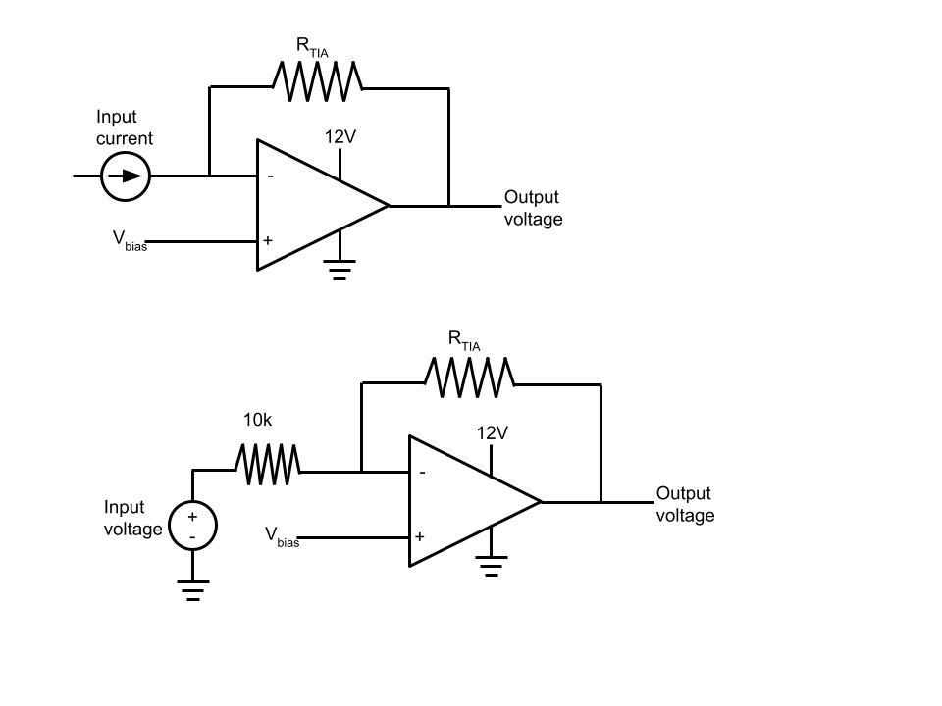

*Figure 2.1: Modifying a TIA circuit to be an inverting amplifier*

The gain equation of the inverting amplifier is $V_{out}=-\frac{R_{TIA}}{10k}(V_{in}-V_{bias})$. A fixed input voltage is applied through the 10k resistor and the measured output voltage is used to calculate $R_{TIA}$.

This calibration procedure is performed instead of applying a known optical power and measuring the ADC code because input optical power depends on factors that are impossible to measure without an already calibrated system (such as insertion loss of the optical fiber couplers). This calibration procedure only depends on known factors, which makes it ideal for our use case.

The procedure for calibration is as follows:

1. Power on the evaluation system PCB
2. Connect Butterfly laser, PIC stage, device under test (on PIC stage), computer, and photodiodes
3. Perform a sweep for each photodiode channel and adjust the potentiometer for that channel so that the sweep is not saturating and has a high signal level
4. Tape over all potentiometers to prevent tampering
5. Shut off board, switch everything off
6. Measure $V_{bias}$ by measuring the output voltage of a TIA without input.
7. Using a variable power supply, set a fixed voltage slightly above the bias voltage, record it
8. Connect one side of a 10k 1% resistor to the input of a TIA channel and apply the fixed voltage from the variable power supply to the other side.
9. Record the output voltage
10. Repeat 7-8 for all TIA channels
11. Calculate $R_{TIA}$ for all channels

We arrived at the following measurements that we can apply to calculate channel power in all future measurements:

| **Photodiode Channel** | **Measured TIA gain (kΩ)** |
| --- | --- |
| 0 | 3.81 |
| 1 | 50.24 |
| 2 | 65.83 |
| 3 | 22.55 |
| 4 | 22.02 |
| 5 | 25.59 |
| 6 | 21.62 |
| 7 | 22.31 |
| 8 | 36.64 |
| 9 | 33.60 |
| 10 | 25.87 |
| 11 | 27.53 |
| 12 | 25.59 |
| 13 | 28.06 |
| 14 | 93.52 |
| 15 | 27.61 |

*Table 2.1: TIA Gain Resistor Measurements*

It is important to note that these can be set independently and changed at will, but these specific values are important to note because this calibration was used for the rest of the tests involving photonic input to the system.

This test satisfies RS-1 because it establishes calibration that we can use to take precise measurements for the remaining tests. To apply it to other tests, we can apply the equation for $P_{optical}$ derived earlier with our gain resistor and bias voltage to compute our power measurement from the ADC code we measure.

The transfer characteristic of the amplifier is given as: $V_{out }=V_{bias}-P_{optical}R_{PD}R_{TIA}$, where a greater amplitude of light input will result in a reduced output voltage, until saturation is reached at 0V. The optical responsivity of the amplifier can be calculated as $\frac{dV_{out}}{dP_{optical}}=-R_{PD}R_{TIA}$ and is given in the table below.

| **Photodiode Channel** | **Optical responsivity (mV/mW)** |
| --- | --- |
| 0 | -3.425 |
| 1 | -45.22 |
| 2 | -59.25 |
| 3 | -20.30 |
| 4 | -19.82 |
| 5 | -23.03 |
| 6 | -19.46 |
| 7 | -20.08 |
| 8 | -32.98 |
| 9 | -30.24 |
| 10 | -23.28 |
| 11 | -24.78 |
| 12 | -23.03 |
| 13 | -25.25 |
| 14 | -84.17 |
| 15 | -24.85 |

*Table 2.2: Optical Responsivity Measurements*

## 2.2 TIA Noise

The minimum optical signal that we can resolve is largely limited by the noise in our TIA circuit. This noise is electronic noise, but it can be converted to equivalent optical noise floor by determining the power required to output the standard deviation of the noise. We can also calculate the effective number of bits (ENOB) of the TIA circuit. Measuring this noise is important to check against the predicted performance in our design and to confirm that our requirements are met (RS-9).

The procedure to measure this is as follows:

1. Power on evaluation system PCB with nothing connected (no photodiodes, laser, or PIC stage), connect to computer
2. Start GUI software and set it to log data
3. Save data over 10 minutes
4. Measure standard deviation of data, calculate equivalent optical noise floor

To determine the equivalent optical noise floor, we compute the standard deviation of the raw ADC counts, then we compute the equivalent power of it by multiplying it with the sensitivity of the optical front end using the calibration information that we found in section 2.1:

$P_{noise}=\frac{σ_{code}V_{ref}}{R_{TIA}R_{PD}(65535)}$

We also can compute effective number of bits by determining how many bits our raw noise takes up and subtracting that from the dynamic range of our ADC:

$ENOB=16-\log_{2}(σ_{code})$

We found that the equivalent optical noise floor is about -45 dBm and the ENOB is 15.5 bits. This meets our requirement RS-9. We plot a histogram of channel 0’s noise in Figure 2.Y.

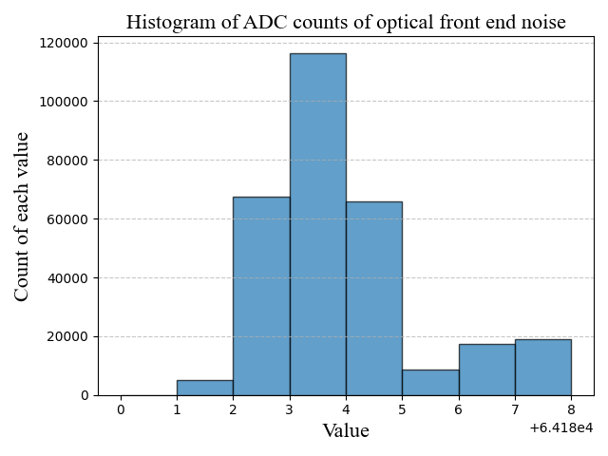

*Figure 2.2: Histogram of ADC counts with zero input. The X axis shows the measured ADC value and the Y axis shows the number of times each value occurred during the noise profiling test.*

## 2.3 PD-TIA-ADC Basic Functionality

To test the basic functionality of the PD-TIA-ADC circuits, one PD on the PRX board is connected to the tunable laser source (TLS) to capture voltage measurements. This test setup is illustrated in Figure 2.3. The exact testing process is described below:

1. Connect Keysight Tunable Laser Source output fiber to photodiode input on PRX board
2. Connect the power barrel jack to the PRX board
3. Connect the USB connector on the Nucleo board in the PRX board to the computer
4. Run read_pd.py, which opens command line communication with the PRX board
5. Set power to 0.05mW on the Keysight Tunable Laser source
6. Turn on laser output
7. Enter input power into terminal
8. Increase laser power by 0.05mW
9. Repeat steps 7 and 8 until power is 1mW (0 dBm)
10. Plot data in CSV file with the power axis in linear units
11. Repeat over all photodiodes

The result of this test is shown in Figure 2.4, where we convert the ADC readings into power measurements using the previously acquired calibration values. A clear linear relationship between the input power and the output voltage of the TIAs is observed. This test establishes that the basic functionality of the PD-TIA-ADC circuit is operational. Specifically, the ADC can properly measure the TIA output voltages and the TIAs are working properly. This further confirms requirement RS-1 which is the ability to acquire photonic power measurements.

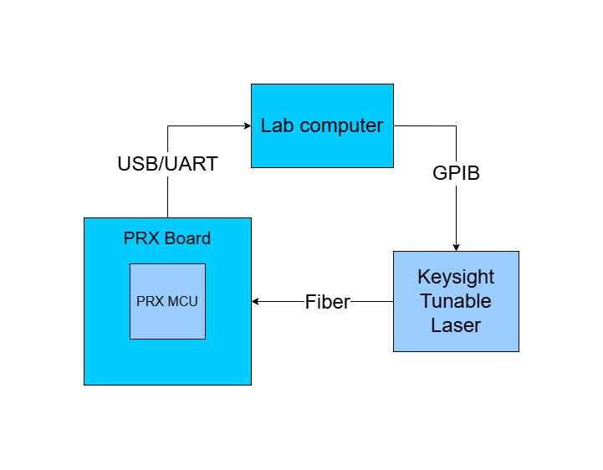

*Figure 2.3: PD-TIA-ADC Basic Functionality test setup. This setup was used for validating the calibration.*

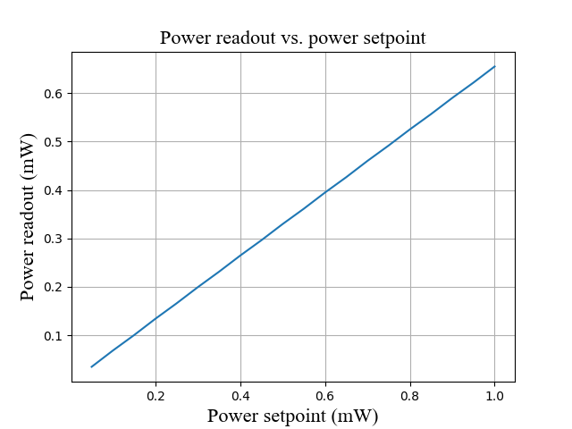

*Figure 2.4: PD TIA Power Response vs controlled input power. As expected, the measured power is a bit less than the power from the laser due to optical fiber insertion loss.*

The values read out by the evaluation system vary linearly with the input power which indicates that the optical frontend is linear. The power readout of the system is consistently about 40% smaller than the power being output by the tunable laser, which can be explained by the standard characteristic insertion loss of the optical fiber couplers which can vary anywhere from 1dBm to 3dBm even with proper cleaning. The optical fiber couplers used were lower quality couplers from AliExpress, and better results may be achieved in the future by using some higher quality couplers that the photonics group has.

## 2.4 Laser Characterization Comparison

Before one can use a butterfly laser for use in the evaluation system, its response to different current impetus must be characterized. Characterization is done by generating an “LI curve” which is the output power against input current. For our purposes, the output wavelength must also be profiled against input current. For these results to be valid, the laser must be controlled to the temperature which is to be used in the evaluation system, in this case 22.915°C. The laser temperature and current are controlled using a Stanford research systems laser diode controller (SRS). The laser’s output power is measured with a keysight N77 photodetector, and the laser’s wavelength is measured using an HP/Agilent wavelength meter. The procedure to perform such characterization is as follows. These characteristic curves will be curvefit which will be used for post processing.

1. Place butterfly laser in a mount
2. Connect current and TEC DSUB connectors to an SRS laser diode controller
3. Connect optical fiber to N77 photodetector
4. Connect SRS and N77 to the lab computer through GPIB
5. Measure LI curve
6. Connect optical fiber to an HP wavelength meter
7. Connect HP wavelength meter to the lab computer
8. Measure current wavelength curve

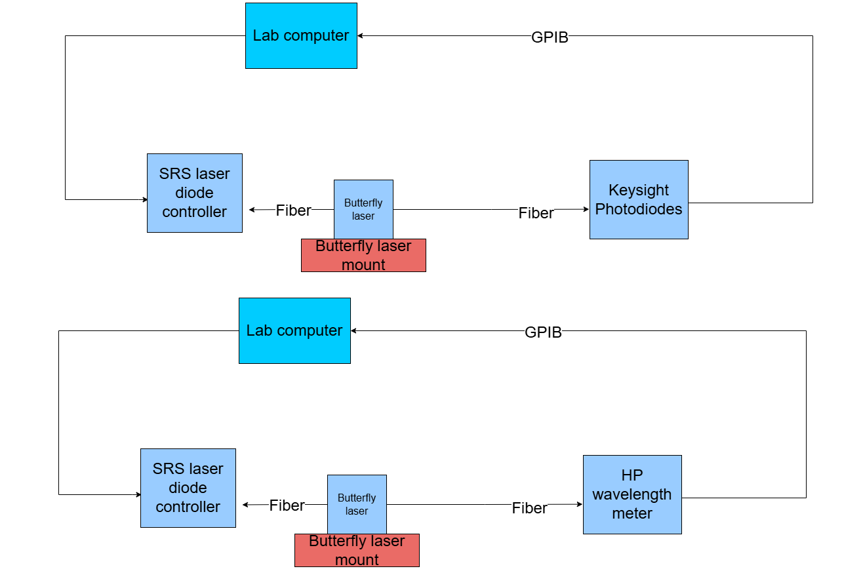

*Figure 2.5: Laser Characterization Test Setups. The top shows the setup used to generate the LI curve of power vs input current. The bottom shows the setup used to generate the laser current vs wavelength curve.*

Performing this test yields a classic laser power curve as seen in Figure 2.6, which transitions from zero output power at low currents to a linear curve at higher currents. Provided that the laser is held at a given temperature, the relationship between current and wavelength on the laser is expected to be approximately linear. The measured current wavelength relationship is shown in figure 2.7.

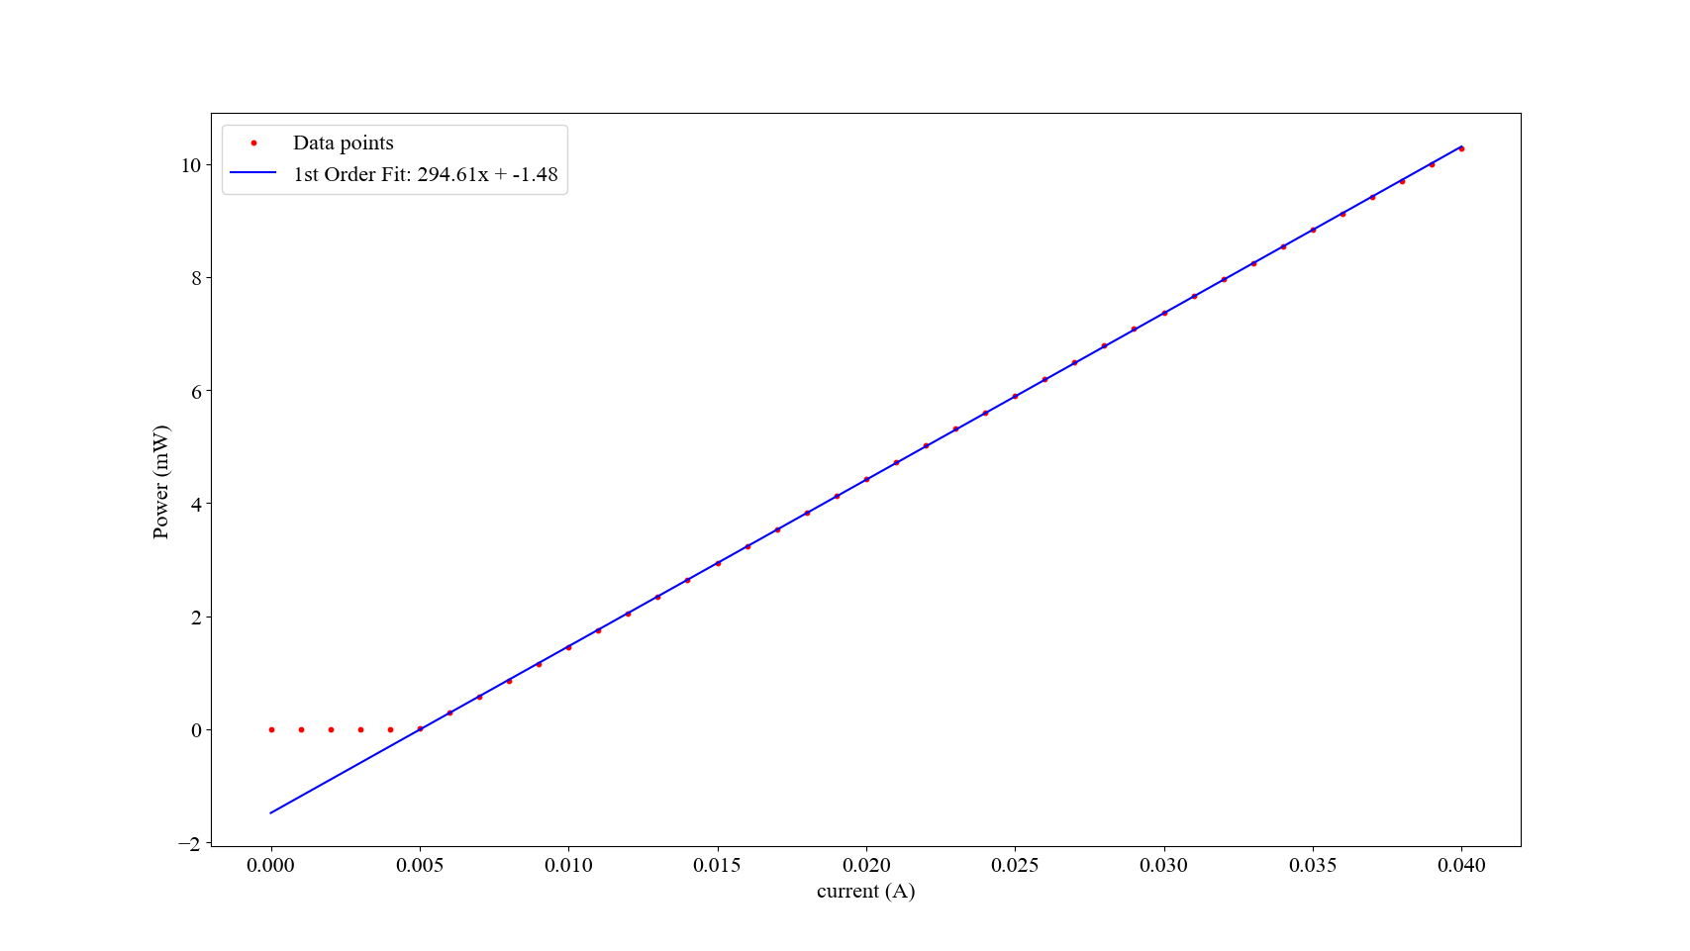

*Figure 2.6: Laser LI-Curve with a curve fit and fit parameters superimposed on top. Fitting was performed after data point number 5, to only represent the region where the laser is “on”.*

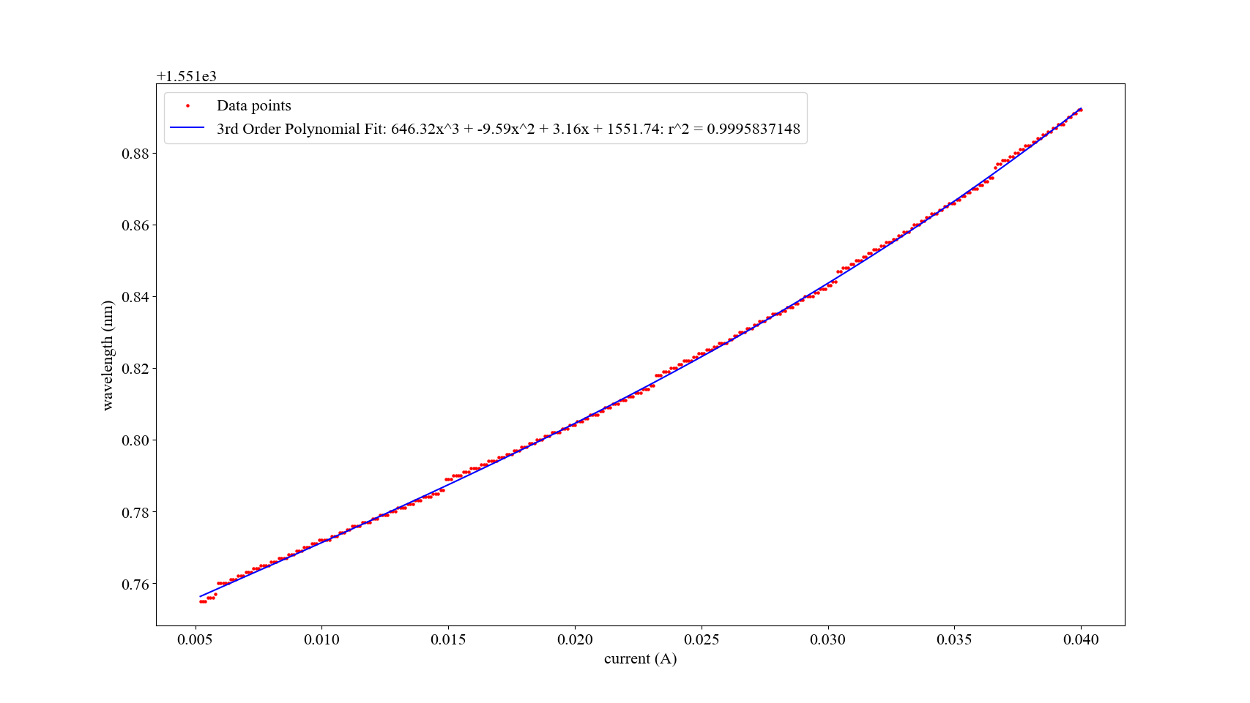

*Figure 2.7: Current-Wavelength Tuning Effect. The curve fit and curve fit parameters are shown. A linear curve fit may have been sufficient, but slight nonlinearity can be accounted for with a higher order fit.*

## 2.5 Sweep Repeatability

The repeatability of sweeps is a test where we perform many sweeps on a fiber Fabry-Perot using the butterfly laser package controlled by our hardware, and then overlay them on top one another to determine how much the peak location changes between sweeps. Thermal noise on the laser will manifest as wavelength shifts in the laser’s output wavelength, and thermal noise on the resonator stage will manifest as the spectrum shifting, both of which will cause the observed peak to shift back and forth on the x-axis.

If our sweeps are sufficiently repeatable, that verifies that temperature drift is well-controlled and this shifting is minimal, which proves our system’s ability to sweep out temperature-sensitive photonic devices and that GS-3 and RS-3 are sufficiently met.

The procedure for this test is as follows:

1. Set the evaluation system PCB up for a sweep (connect laser, plug in photodiode(s), connect stage TEC and thermistor, connect power, connect fiber input/output to fiber Fabry-Perot)
2. Plug evaluation system PCB into computer and launch the GUI application
3. Enable the stage and LDC temperature controllers and wait for them to settle
4. Configure the sweep parameters (start = 1000, stop = 4000, step = 1, number of sweeps = 50)
5. Run sweep
6. Save recorded data

The measurement setup for such a test is shown below in figure 2.8.

We then plot all the sweeps on top of one another, as shown in Figure 2.9. We plot them with respect to laser setpoint current and with respect to predicted laser wavelength using a mapping between current and wavelength tuning that we previously acquired. The spectrum is quite stable, with the maximum wavelength showing very little variation between sweeps. Across 50 sweeps, the standard deviation of the maximum wavelength is 0.2pm, which meets our requirement RS-3 (see Figure 2.9). RS-2 is also satisfied as this test shows that our system can resolve wavelength differences above 0.2 pm, which is better than 1 pm.

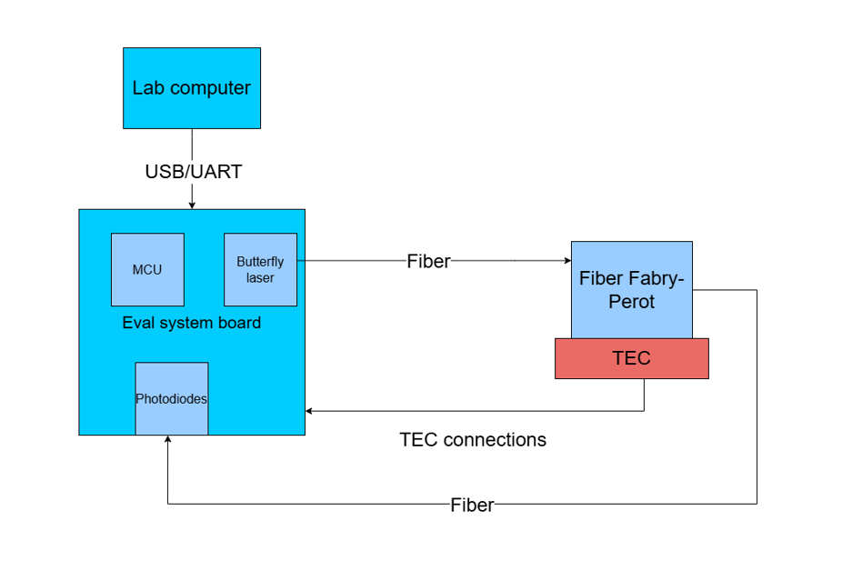

*Figure 2.8: Sweep setup for sweep repeatability test*

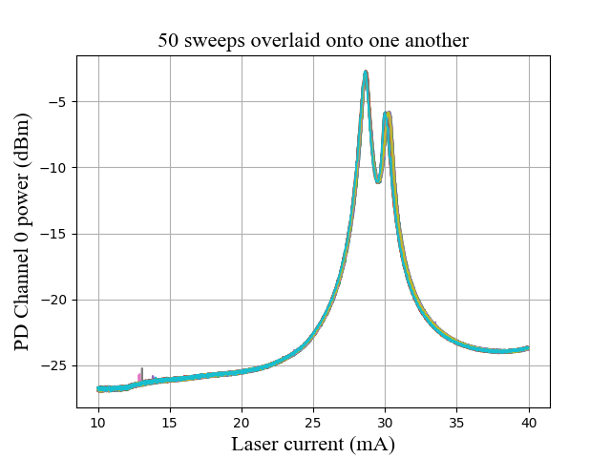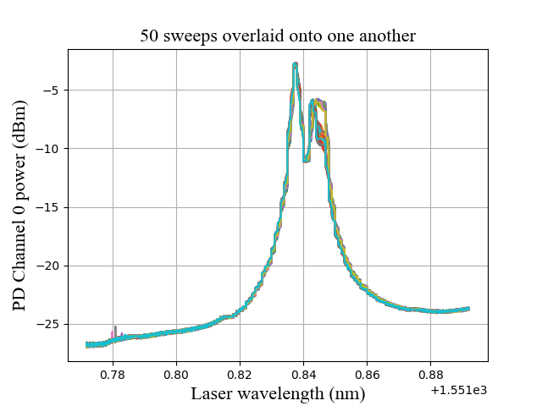

*Figure 2.9: Sweep repeatability test with respect to laser current (left) and laser wavelength (right). Each of the different coloured overlaid lines on both figures correspond to a unique sweep to allow for visibility. Power output is in dBm and wavelength is in nm, current is mA.*

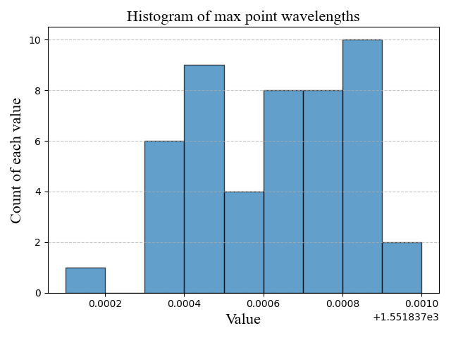

*Figure 2.10: Peak wavelength histogram, with the x axis showing the bins for measured peak wavelengths, and the y axis showing the frequency of those bins in the 50 sweep test*

## 2.6 Comparison with Benchtop Setup

An essential test is the system’s ability to recreate the performance of a benchtop optical sweep setup. In photonics research, a device’s transmission spectrum is characterized by sweeping across it with a 0dBm tunable laser, and measuring the output optical power with a photodiode. To produce comparable results with the evaluation system, the measured spectrum must be normalized with respect to the power of the input laser. Successful normalization will get the same results that would be achieved if the evaluation system were able to output constant power across its full wavelength span. A fiber Fabry Perot resonator was swept using the evaluation system with a setup shown in figure 2.12 , and the benchtop setup is shown in figure 2.11. After performing the sweep, the output was normalized with respect to the laser’s current vs power relationship as characterized in section 2.4. The ability to use the hardware system combined with post processing to achieve the spectrum of a resonator as characterized by a benchtop setup is verification of RS-1. The appropriate wavelengths corresponding to each part of the sweep was determined using the current vs wavelength relationship as characterized in section 2.4. To represent the gold standard benchtop setup, a keysight tunable laser was used with keysight photodetectors to sweep the same peak on the resonator, with the fiber Fabry Perot being temperature controlled by the evaluation system. For both tests, the fiber Fabry Perot was controlled to 23°C with less than 0.001°C temperature variation measured by the controller.

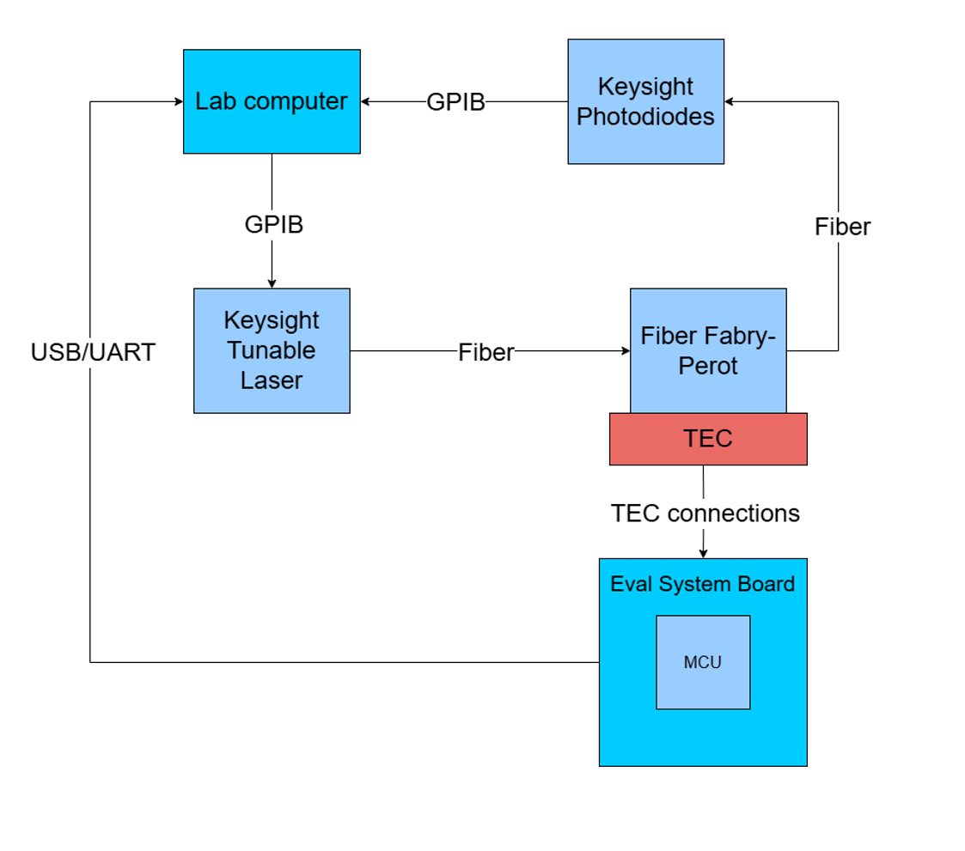

*Figure 2.11: Benchtop setup to characterize fiber Fabry Perot*

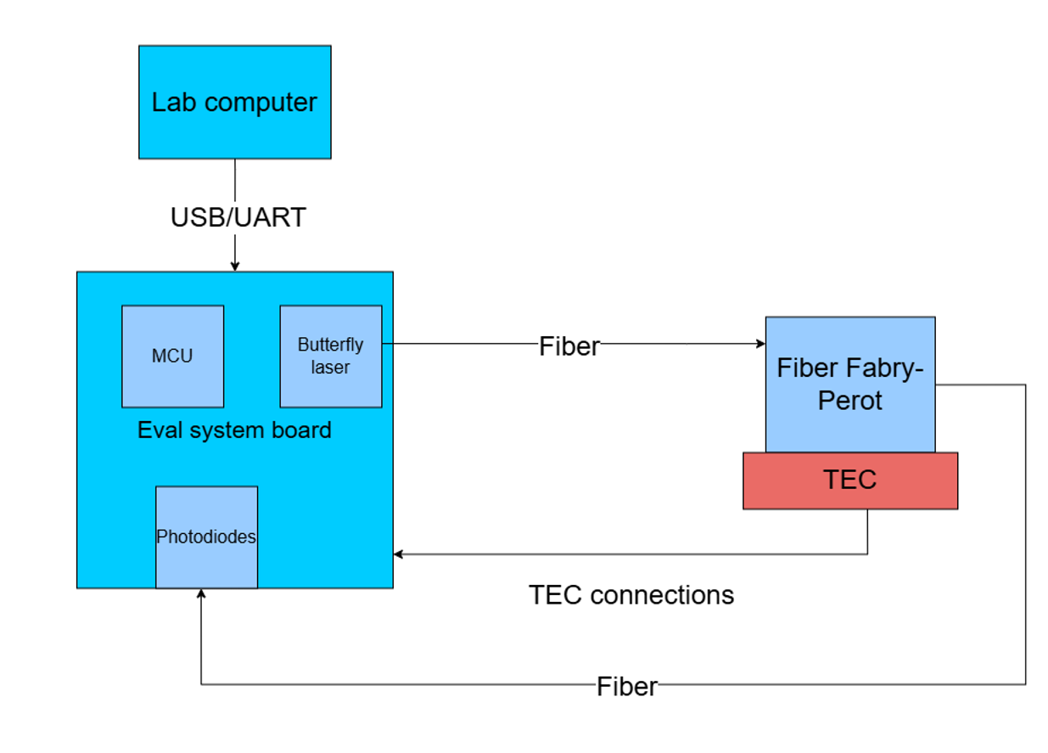

*Figure 2.12: Evaluation system setup to characterize fiber Fabry Perot*

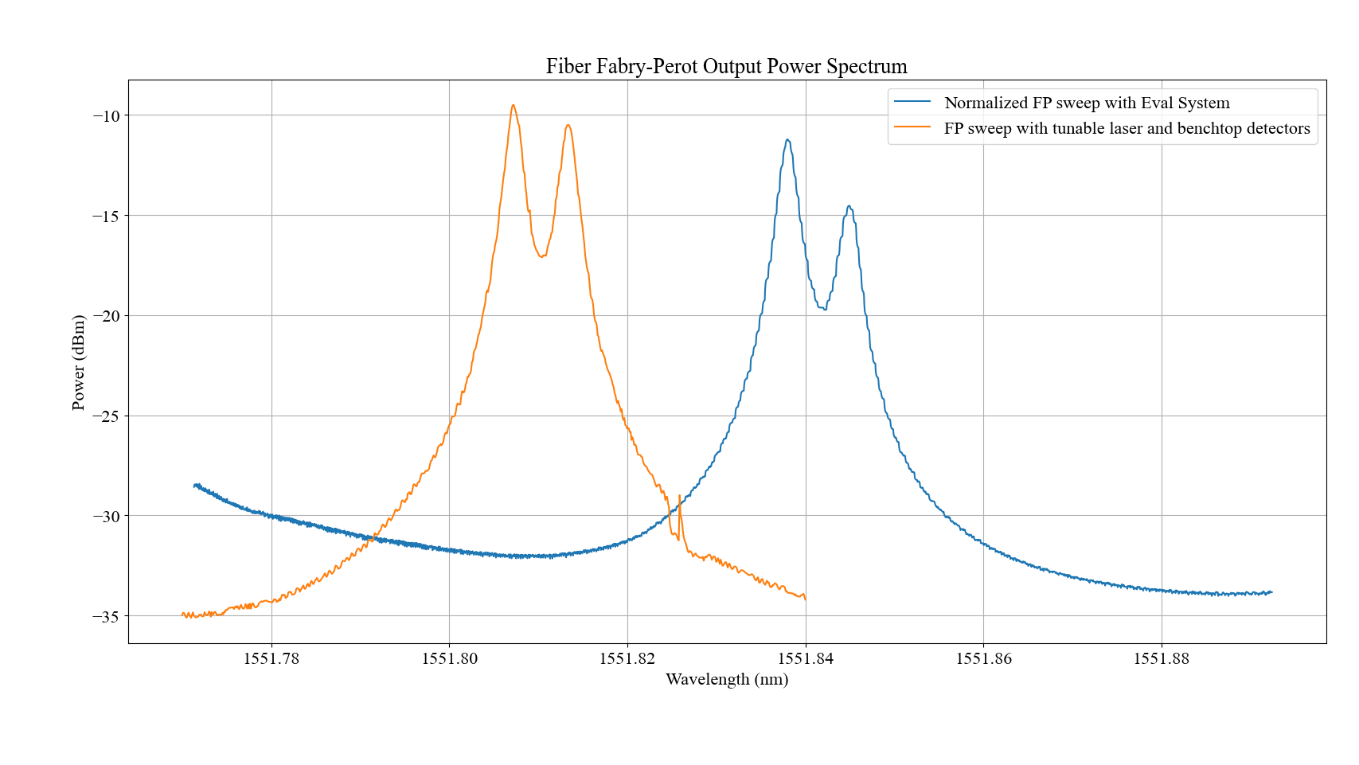

*Figure 2.13: Comparison of sweep results from benchtop setup and custom setup. The power in the Eval System sweep is normalized with respect to input power. SThe spectrum are very similar, with the peaks being at different powers due to different kinds of connections in the two systems. The wavelength offset is due to the benchtop equipment not being calibrated properly.*

The spectra are strikingly similar, with some obvious differences. The peaks are at slightly different values of power, which can be explained by frequency dependent insertion losses due to the different fiber connectors that were used between the two setups. The spectrum acquired with the evaluation system appears to occur 40pm higher than the spectrum acquired by the benchtop setup. This difference can be explained by the fact that both the tunable laser source and the wavelength meter are due for calibration. The need for calibration on the wavelength meter could bias the measurement of the current wavelength tuning effect to measure slightly higher wavelengths. The need for calibration on the tunable laser could have also biased the tunable laser by outputting slightly higher wavelengths than the setpoints defined by the user. A better match between results could be achieved by using instruments that have been calibrated more recently.

This test can also be used to verify goal GS-2 by postprocessing and counting how many data points fall within the FWHM (full width halfmax) of the peak. The first sweep from the sweep repeatability test section was used, and it was found that 38 data points fall within the FWHM region of the sweep. This number provides excellent potential for curve fitting the resonator that is being used in this verification experiment. Further work will be needed to determine how many points fall within the spectrum of the chip that the SOC lab uses for their biosensing experiments.

## 2.6 Laser Temperature Control

To verify the laser temperature controller, we test our closed loop PID controller with the laser current being swept to determine how well it regulates the temperature relative to the setpoint. This is a good test because increasing the laser current results in a higher optical output power which heats the laser up, testing our controller’s ability to counteract that. This test is directly relevant to the requirements and goals pertaining to temperature control (RS-4 and GS-6), as well as indirectly to the requirement pertaining to the repeatability of measurements (RS-3). This is because we require the laser’s temperature to be very stable if tests are to be repeatable.

The procedure for this test was as follows:

1. Plug the laser into the PRX board and connect the PRX board to the lab computer using USB
2. Turn on the TEC Controller switch on the PRX and turn on the TEC Controller on the GUI and let the controller run for 5 minutes to ensure it reaches a steady state (with the laser not being fed any current)
3. Run 50 sweeps with the GUI that feeds the LDC with commands to step the laser current from 10mA to 40mA in a triangle wave at 0.3Hz and measure the laser’s temperature after every DAC step.

The results of this test (with all 50 sweeps overlaid) are shown in Figure 2.14, with a summary of the results displayed in Table 2.2. Since our controller is designed to reject disturbances and not to track a moving setpoint, the rise and settle times of the closed-loop response were not measured or analysed.

The controller performs exceptionally well, with our temperature always staying well within the 5mK requirement (RS-4). As seen, the laser package stays within a 4-4.5mK window of the temperature setpoint (22.9185), despite the laser current being swept as fast as possible at the highest wavelength step resolution. This is especially impressive when compared to the laser temperature response with a heuristically tuned PID control attempt, shown in Figure 2.15. As seen in Figure 2.15, the temperature of the laser would swing by about 10mK from the setpoint instead of the much more damped response exhibited now.

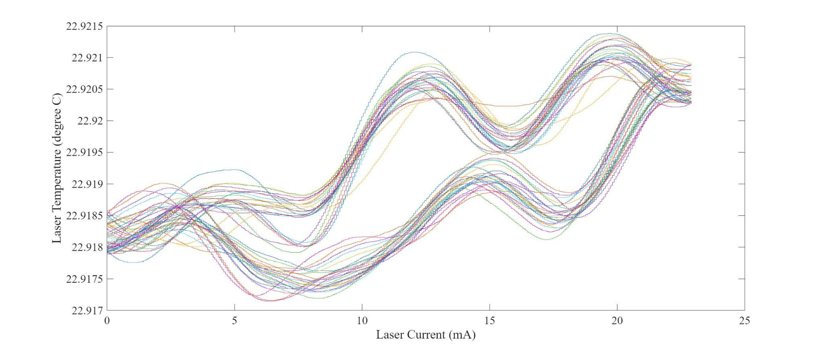

*Figure 2.14: Laser sweep temperature. Each unique coloured line corresponds to a singular sweep of the laser. The y axis is temperature in degrees C and the x axis is laser current in mA.*

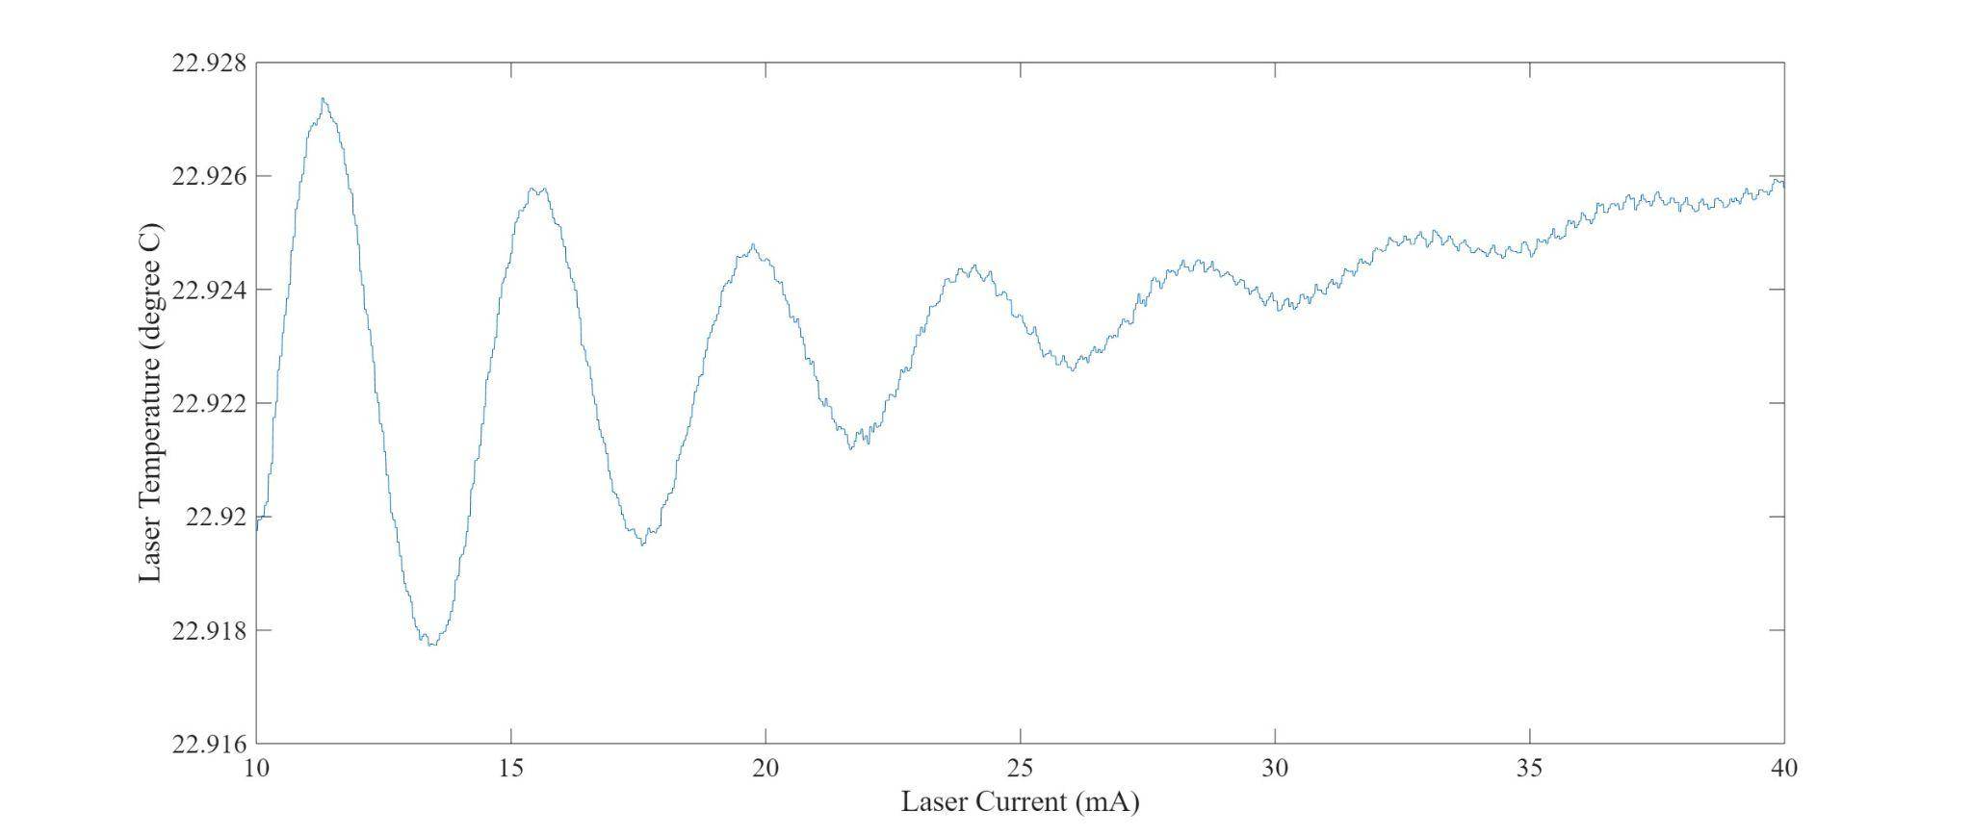

*Fig 2.15: Initial Laser Sweep temperature response. Despite the slightly different laser current range than Fig 2.15, a much worse response is observed*

The mean temperature during all the sweeps, Standard Deviation of temperature measurements and mean error from set-point are calculated (Table 2.3). These are standard metrics for a PID controller’s dynamic response as it compensates for a continuous disturbance in the form of a temperature drift. All of the time is spent within the 5mK window, which is excellent and shows tremendous progress towards accurate temperature control (GS-6).

| Parameter | Value |
| --- | --- |
| Mean temperature in K | 22.919 |
| Mean error from Setpoint (%) | 0.3175 |
| SD (σ) in K | 0.00107 |
| % of time spent within 5mK of Setpoint | 100% |

*Table 2.3: Laser Temperature Control performance summary*

## 2.7 PIC Stage Temperature Control

To verify the thermal characteristics of the PIC stage design, it is controlled using our circuitry during a run of a sweep (the data presented here is the temperature data for the Fiber Fabry-Perot during the test described in section 2.5). Our thermal control requirement (RS-4) may only be achieved if the mechanical system supports our control system and if the control system’s tuning behaves as expected. A larger aluminum plate that came with the TEC assembly is used instead of the TEC Plate machined by our team as we didn’t have a PIC to test with and thus didn’t need the mounting holes. An aluminum PCB with a thermistor is mounted to the larger TEC plate with thermal paste, and the fiber Fabry-Perot is mounted on top of the aluminum PCB, also with thermal paste. The procedure for the test is as follows:

1. Set the evaluation system PCB up for a sweep (connect laser, plug in photodiode(s), connect stage TEC and thermistor, connect power, connect fiber input/output to fiber Fabry-Perot)
2. Plug evaluation system PCB into computer and launch the GUI application
3. Enable the stage and LDC temperature controllers and wait for them to settle
4. Configure the sweep parameters (start = 1000, stop = 4000, step = 1, number of sweeps = 50)
5. Run sweep
6. Save recorded temperature data

The controller dynamic response during the sweep, is shown in Figure 2.16.

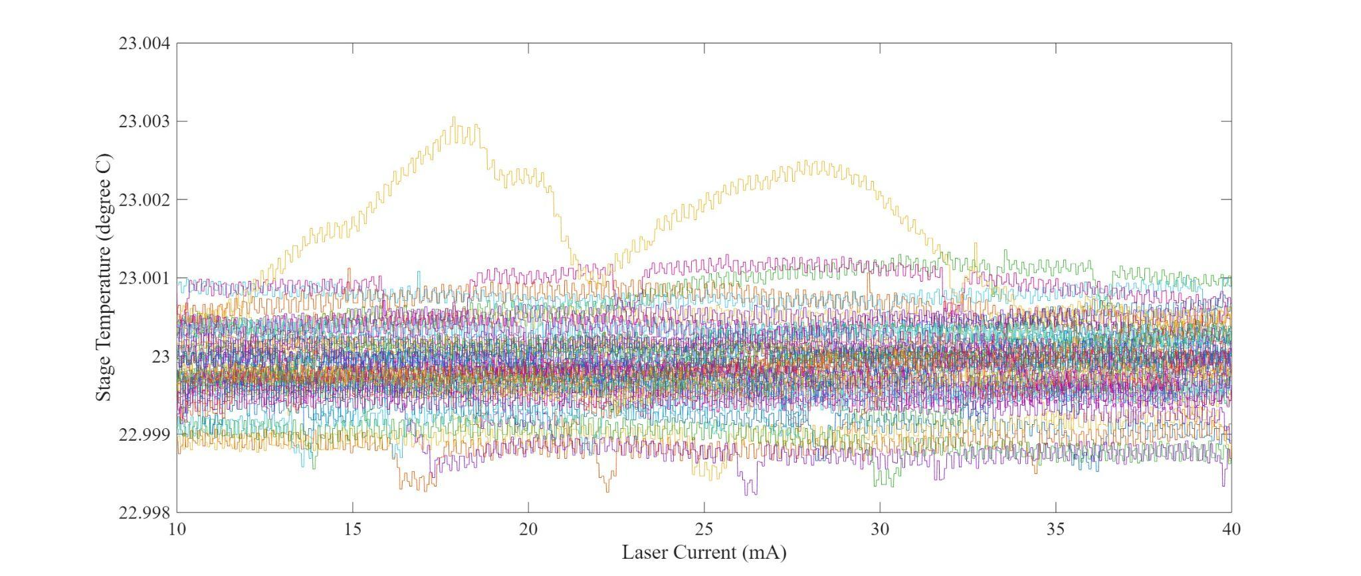

*Figure 2.16: Stage temperature during 50 sweeps of the Fiber Fabry-Perot, overlaid.*

As seen, our stage temperature is within +-1mK of the 23 degree C setpoint for most of the time, spending > 90% of the total test time within that window. Our mean temperature is 22.9999 which is less than 1mK from the setpoint. Lastly, the standard deviation of the temperatures is 5.5E-4 K.

This data strongly meets our repeatability requirement (RS-2) and our temperature control requirement (RS-4) as well as our temperature control goal (GS-6).

# 3 Validation

In order to ensure that our RCGs match the actual needs of the client, we discussed each of them with the client to better understand why these specific RCGs are important.

## 3.1 Requirements

The most important requirements are RS-2 and RS-3. These two requirements encode the core functionality of the project: resolving peaks. Meaningful experiments are not possible without accurate peak detection. RS-1 is a prerequisite for these two requirements and, as such, is a very important requirement itself. RS-4 is necessary for accurate peak detection, since the primary source of noise in both the laser and photonic chip are thermal. Without thermal control, the current-wavelength tuning effect would be completely eclipsed by noise. RS-9 is also essential to make sure RS-2 and RS-3 are possible to achieve. If the noise floor of the photonic measurement is too high, then the peaks will be drowned out in noise, and it will not be possible to effectively locate them, even after using curve-fitting. Finally, RS-10 is also absolutely necessary for being able to resolve peaks. A spectrum can only be swept out by changing the wavelength of the laser, and without a spectrum it is impossible to know where the peak location is.

Since this project is meant to be used by members of the SoC lab, software control and data acquisition is important, so that the device can be used easily by a variety of users who may have little knowledge of how the system as a whole works. Without effective software control, the device is too challenging and cumbersome to use, and hence not useful to the lab. This is why we specified RS-5.

RS-6 is important for the SoC lab members to run experiments on many chips as easily as possible. It also helps with the ultimate goal of having a point-of-care biosensing solutions, where ease of use and quick setup is necessary to have a useful product.  
  
RS-7 ensures that the device can not damage the photonic chips placed into it. This is very important, because the photonic chips take a long time to manufacture, and are very expensive.   
  
RS-8 ensures that the user is easily capable of designing a new controller that is better adapted to the experiment they would like to run. If the controller could not be changed, then the performance on many kinds of experiments would be much poorer than what is possible with proper tuning.

## 3.2 Goals

Increasing sweep speed is important, since it will allow more experiments to be run. This goal is encoded by GS-1. Sweep speed is important for the SoC lab since there is a limited amount of hardware that is shared among many students.

In order to maximize the accuracy of peak detection, the SoC lab uses custom curve-fitting software. Higher resolution improves the results of this curve fitting. Therefore, our system aims to have as high resolution as possible, as dictate by GS-2. Likewise, the more repeatable the peaks are, the more reliable and accurate the measurements are. Therefore, our team introduced GS-3. Furthermore, the more accurately the temperature of the laser and the photonic chip are controlled, the less noise there will be in the measurements, and hence the better the accuracy of the peaks will be. Therefore, GS-6 is quite important.

To make the system as easy as possible to use, goals GS-4 and GS-5 were introduced. These allow members of the SoC lab to run a wide range of experiments with little to no troubleshooting, and very little setup overhead.

# 

# 4 References

[1] “A PCB about the size of a pizza box with a silicon chip in the center,” image generated by OpenAI’s DALL·E 2, (accessed Oct. 09. 2024)

# 

# Appendix A: Glossary

| **Term** | **Definition** | **Context within our project** |
| --- | --- | --- |
| TEC | Thermoelectric cooler | Main actuator for PIC stage temperature control |
| LDC | Laser Diode Controller | Custom hardware designed and built by the client to drive a DFB laser |
| DFB | Distributed Feedback (laser) | A low-cost laser, in a butterfly package in our project |
| PID | Proportional-Integral-Derivative (control) | Control the temperature of the PIC |
| GUI | Graphical user interface | Software to control all aspects of our project and assist in data analysis |
| PIC | Photonic Integrated Circuit | Silicon photonic device to photonically measure biological analytes |
| DAC | Digital-to-analog convertor | Create analog control voltage for TEC controller |
| ADC | Analog-to-digital convertor | Used to capture the output voltages from the PD-TIA circuits and to measure the temperature voltage output from the thermistor analog circuit |
| TIA | Transimpedance amplifier | Used to convert the output current from the photodiodes into an output voltage |
| MCU | Microcontroller | Used to coordinate hardware functions |
| SiPh | Silicon Photonics | The overarching field behind our biosensor |

*Table A.1: Glossary of terms*